IT-520

Michael Weiler

Lab 2

1. 1.1

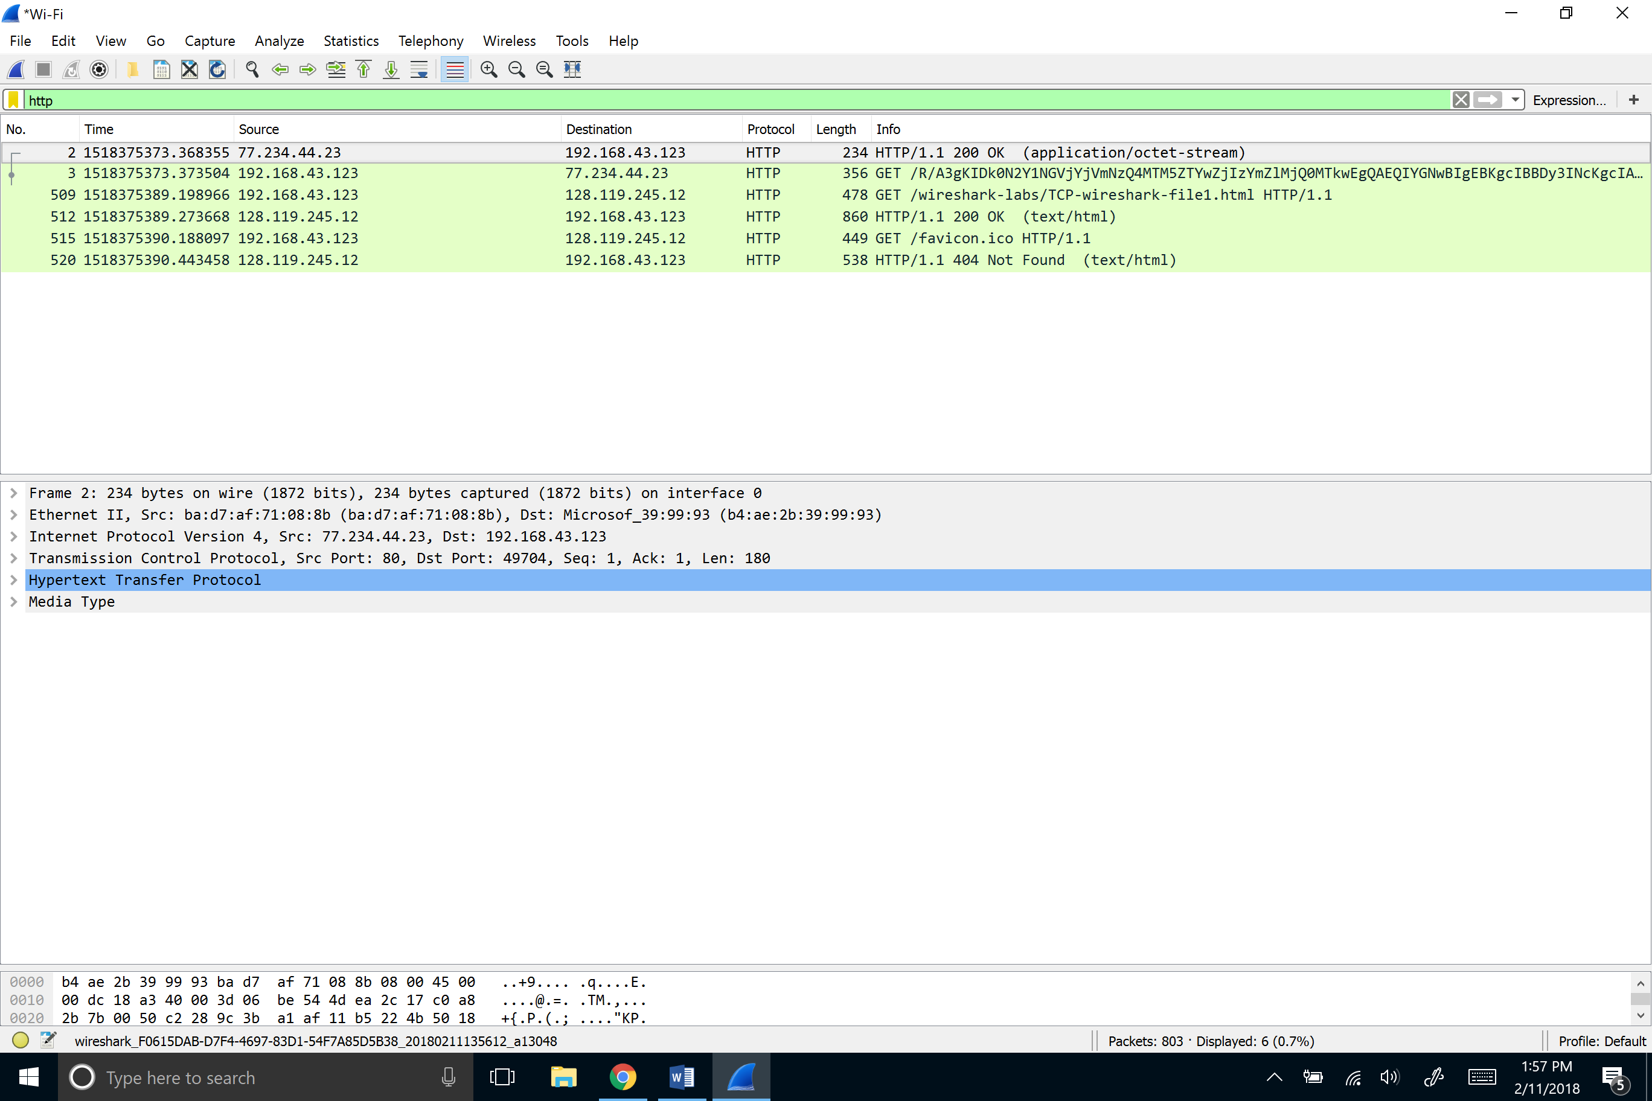

1. See below

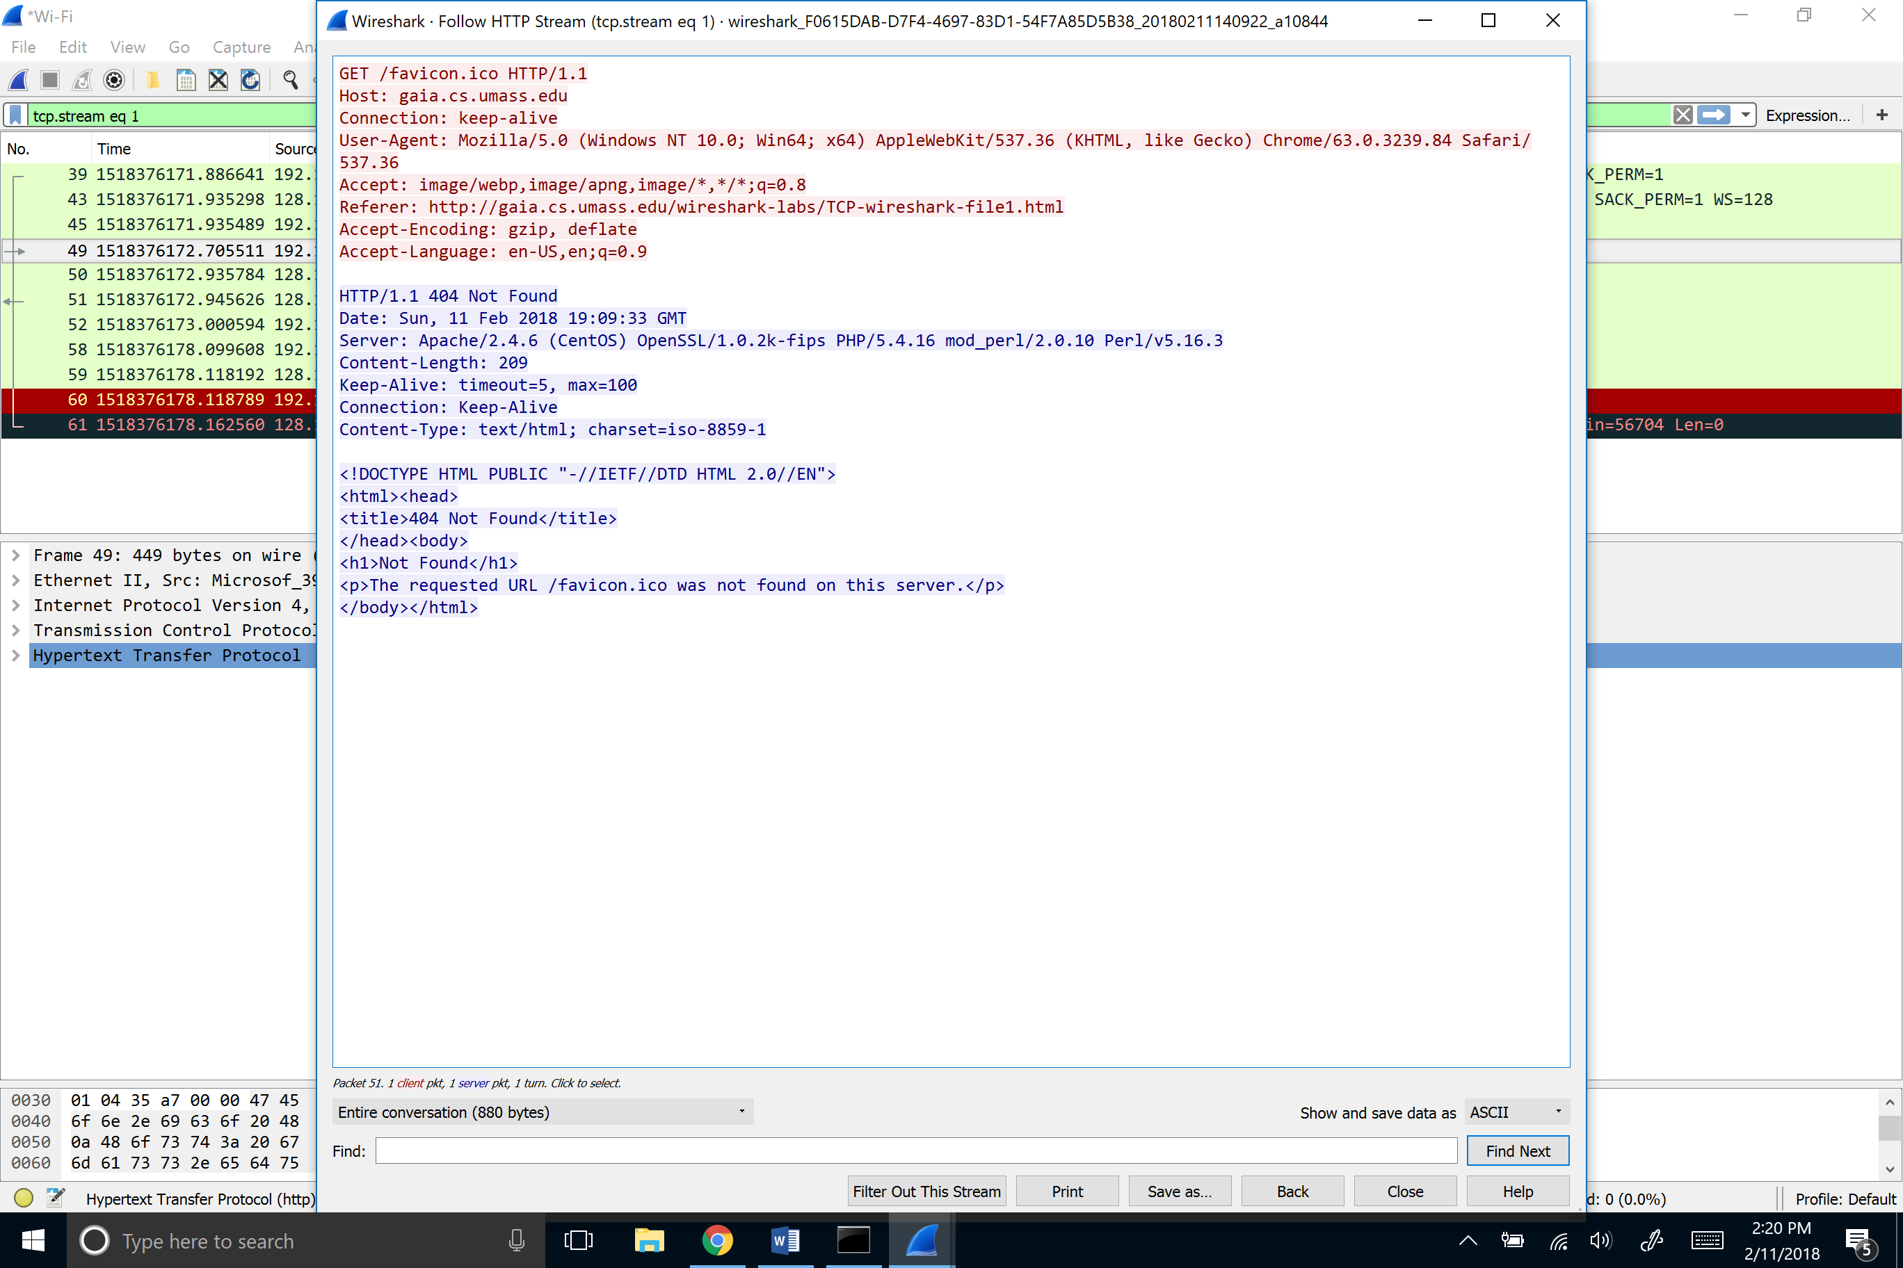

3. 192.168.43.123 128.119.245.12



1. Eng

